# Worksheet for Benchmarking Assignment

Please complete this worksheet and submit it via the D2L Dropbox for the Benchmarking Assignment.

**Document filename: yourname_benchmarking.doc.**

NOTE: Where specific commands are required in the imaging programs, I’ve tried to supply directions in parentheses (e.g., *Choose Image--> Mode --> Select Grayscale*). These programs may vary slightly based on the program, version, and operating system. If you have problems, please see the Program Help. If you’re still confused, contact me and I’ll do my best to supply the appropriate commands.

**For questions 1-2, refer to image named “Wedding Image”**

1. Describe the original photograph. (Refer to the Cornell tutorial for appropriate terminology)
   1. Based on what you see (defects and all), what kind of original was this likely to be? A Photograph with fading/ chemical damage around the borders. The photograph also contains “speckles” probably from chemical damage from deterioration or being in contact with a rough surface.
   2. What are the important characteristics of this type of original? (e.g. details, exposure, color cast, photographic finish, dynamic range, etc.) How would you characterize it tonally? Important characteristics are the details in the clothes and the deterioration within the photograph. It has a yellowish colorcast and a bluish grey colorcast around the borders. There is a transition from light to dark and you can see most of the details in the darker and lighter shades. Although some areas do look to dark and light for detail. The dynamic range is broad and for photographic prints it is typically 1.6-2.3. The photographic finish looks glossy and It is a continuous tone document.
   3. If you were to digitize the original image, what characteristics would be most important to capture and how would that relate to the choice of resolution and bit-depth? I would want to capture the details in the clothes to help identify time period and also capture the fading and speckling to help authenticate it as an older photo. I would also want to try to capture the exact tone and colors. I would want a higher resolution to produce more pixels for a clearly detailed image. I would want to use 8-bit depth to capture the grey tones, or a 24-bit depth to help capture the color-cast in some areas.
2. If the dimensions of the original are 3” w x 5” h:
   1. Calculate the pixel dimensions it would take to scan the document at 300dpi.

(3 X 300) =900

(5 x 300)= 1,500

900 X 1,500

* 1. Calculate the pixel dimensions it would take to scan the document at 600dpi.

(3 x 600) = 1,800

(5 x 600)= 3,000

1,800 X 3,000

* 1. What approximate size, in both bytes and kilobytes (remember to use a factor of 1024, not 1000 when converting from bytes to kilobytes), would the file be if you scanned it at:

|  |
| --- |
| **File Size = (height x width x bit depth x dpi2) / 8** |

(3 x 5 x 1 x 3002)/8 = 168,750 bytes (168,750 ÷ 1,024) = 165 KB

(3 x 5 x 1 x 6002)/8 = 675,000 bytes (675,000 ÷ 1,024) = 659 KB

(3 x 5 x 8 x 3002)/8 = 1350000 bytes (1350000 ÷ 1,024) = 1,318 KB

(3 x 5 x 8 x 6002)/8 = 5400000 bytes (5400000 ÷ 1,024) = 5,273 KB

(3 x 5 x 24 x 3002)/8 = 405,0000 bytes (405,0000 ÷ 1,024) = 3,955 KB

(3 x 5 x 24 x 6002)/8 = 16200000 bytes (16200000 ÷ 1,024) = 15,820 KB

|  |
| --- |
| **Refer to the formulas in the Cornell tutorial:**  **basic terminology> key concepts> pixel dimensions> file size** |
| **NOTE: Include the formula you used, and your calculations** |

|  |  |  |  |  |
| --- | --- | --- | --- | --- |
| **Image Type** | **300 dpi (in bytes)** | **300 dpi (in KB)** | **600 dpi(in bytes)** | **600 dpi (in KB)** |
| **1-bit bitonal** | 168,750 bytes | 165 KB | 675,000 bytes | 659 KB |
| **8-bit greyscale or color** | 1350000 bytes | 1,318 KB | 5400000 bytes | 5,273 KB |
| **24-bit color** | 405,0000 bytes | 3,955 KB | 16200000 bytes | 15,820 KB |

1. Open image: **“Text and photo image”**
   1. What are the important characteristics of this type of original? (e.g. color cast, condition, dynamic range, etc.) How would you characterize it tonally? It is in good condition with no color cast. The text is clear and the image doses not have much detail in the shadows and highlights. It is a combination of text which is bitonal and a halftone image. Because it is mixed the dynamic range could be between 1.5-1.9 and has a lower dynamic range.
   2. If you were to digitize the original image, what characteristics would be most important to capture and how would that relate to the choice of resolution and bit-depth? Text is extremely important so it would require higher resolution for clear and sharp text. The halftone image contains moiré so it would need a higher resolution to produce more pixels to fill in the moiré with detail. It would need to be scanned at 8 or 16 bit to produce grey scale scanning to capture both text and image details.

How would you measure those characteristics, so that you could benchmark for them? Since it is a mix document it requires grey-scale tones to accurately render both. I would want to benchmark for 8 bit depth. Since it is a mixed document you would need to measure more then one area of the page. You would need to measure the smallest character of text and the halftone screen ruling of the image to help figure out resolution. Usually 4 times screen ruling. For half tones a recommend 400-600 DPI is recommended at 8 bit depth. To benchmark for text in grey-scale I could use the formula below to help determine resolution.

dpi = 3QI/.039h

h=smallest character

QI=quality; where 8 is the highest

1. Open image: **“Manuscript page image”**
   1. What are the important characteristics of this type of original? (e.g. color cast, condition, dynamic range, etc.) How would you characterize it tonally? Page has a few stains over some lettering. It has a yellow color-cast due to age. Lettering is faded in some areas. There is a low contrast between background and text. There is not much transition between light and dark so dynamic range is limited.
   2. If you were to digitize the original image, what characteristics would be most important to capture and how would that relate to the choice of resolution and bit-depth? Clear text is the most important characteristic for this document. I would want to capture it so that the text shows up clear and that stains don’t interfere with the reading of text. I would want a higher resolution to capture text details that are fading and are difficult to read. Capturing the age of the document is also an important factor to its authenticity but doesn’t seem necessary in this case. I would want to use 8-16 bit depth to capture important information in grey-scale without creating a really huge file.
   3. How would you measure those characteristics, so that you could benchmark for them? I could benchmark for 8-16 bit to capture the image for color or grey-scale. You would need to measure for the finest stroke to calculate a resolution best for the text.

DPI= QI/.039W

QI=2

You would want to use 2 because it represents excellent quality.

1. Open images: **“Color target01 image”** and **“Color target02 image”**

1. Why might a color/grayscale target be included with these images?

It is used to compare the colors of the image to distinguish any color shifts or to calibrate monitors and printers.

1. What is the bit depth of each image? (*Image-->Mode*)

Color target01= 8 bit

Color target02= 8 bit

6) For image: **“Color target02 image”**

* 1. Open the image histogram (*Window--> Histogram*). Experiment with the brightness/contrast adjustments (post-processing options). (*Image-->Adjustments*).
  2. What happens to the image when you adjust the brightness? (Be sure to look at the color bar too). Explain why brightness/contrast functions might be used and why they should be used sparingly. When you adjust the brightness the color becomes lighter and lighter. When you adjust the contrast to the left the color starts to disappear till it is not there anymore. When shifted to the right colors are overly saturated turning them to just primary colors. Using this in small increments is useful to adjust the color if it is off. If brightness and contrast is used to heavily the colors are changed dramatically and the lighter and darker areas are clipped. Detail is then lost so this is destructive to the image.
  3. Now focus on the caption of the picture (*View > Zoom In*) Do you notice anything about the text? Describe what you see. Discuss some reasons why the text might appear as it does. The letters become more pixilated and blurred. The closer I get the less recognizable detail I see. When scanning, resolution could have not been set high enough to pick up the detail. The file also was saved as a gif, which is a very compressed file for a color image. Information, details and pixels where compressed/ discarded in order to shrink file size.
     1. Open image **“Beach image”,** note the image size.

*(This info is usually found in the lower left hand part of the Photoshop window)*

**Each exercise below should be performed on this file**

* 1. Using Photoshop or Photoshop Elements, duplicate the image (*Choose Image--> Duplicate*).
  2. On the copy, change it from a 24-bit color file , to 8-bit, to 1-bit, 400 dpi, B/W image via a 2-stage process:
     1. *Choose Image--> Mode --> Select Grayscale*. Discard color info? Choose Discard.
     2. *Choose Image--> Mode --> Select Bitmap. A pop-up will appear. Make sure it says “400” in the output “pixels/inch” box.*

What happens to the file size?

The file size gets smaller because color information and pixels have been discarded. The file size goes from 16 m to 1.86 m

Still on the copy, choose “Save for Web” *(File-->Save for Web)* or “Save As” *(File-->Save As).*  If using Save for Web, Choose to Save it as “JPEG,” “Medium Quality” *(or quality=30).* ***Rename the file! Save it as: Beach_file0001_jpg.***What happens to the file size?

The file gets bigger but still smaller from the original. The original was 16.8 mb and it is now 7.9 mb.

* 1. Go back and open the original file (“Beach image”) and the new image (copy) created above in 4b (Beach_file0001_jpg) and look at the images. [View them at about 16.7% - View--> Zoom in or out to get there.] Can you perceive a difference in quality in the two?

yes the copy looks grainy and less smooth.

* 1. Look at the histograms for the two images (*Window-->Histogram*). Click on one image and view the histogram. Now click on the other. Did you observe any differences? If so, what? The original histogram has information available from the left to right with a heavier concentration on the right. The copy has some information on the right and left but nothing in the middle values.
  2. **Repeat step a:** create a new duplicate and change the image to grayscale (*Choose Image--> Mode --> Select Grayscale*). On the new copy, choose “Save for Web” and this time, save it as a GIF file (**rename it: Beach_ file0001_gif**).
  3. Open all three files onto the Photoshop workspace. Compare all three. Are there compression artifacts visible in the JPEG version? In the GIF version? Make sure to provide details to support your answer.

The jpeg loses a great deal of detail and information compared to the GIF. The jpg turns into a dot drawing when viewed up close. It has a great deal of moire and a lot of detail is missing filled with white and black space. 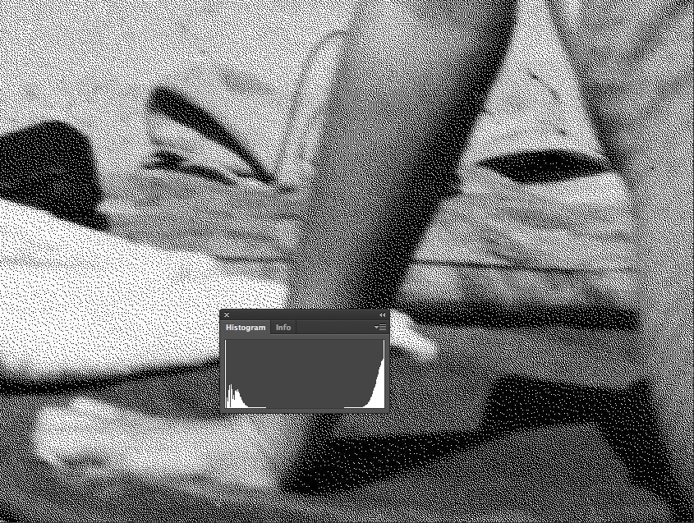

**Jpg 100%**

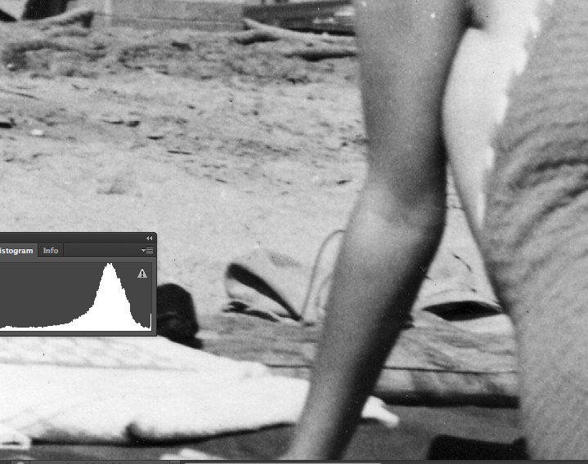

**GIF 100%**

The GIF on the other hand does lose some detail when compared to the Tiff but not as substantial then the jpg. I can see that the darker areas on her arm and the sand in the background lose detail as a GIF than as a TIFF.

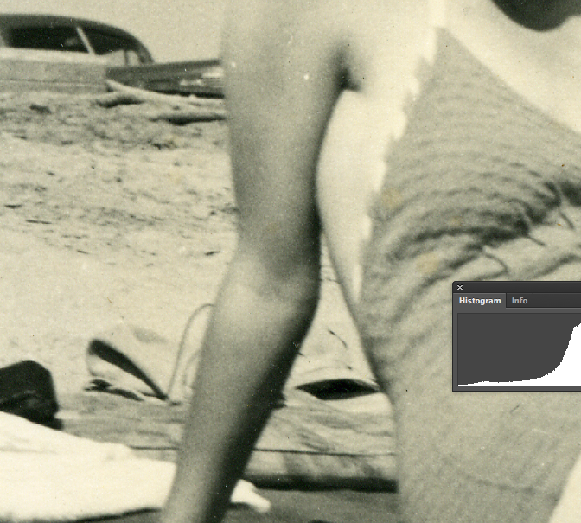

**TIF 100%**

**NOTE: include samples from your images here to support your answer**

* 1. Choose a particular section of the image. Using the Zoom tool (*or View-->Zoom In*), zoom into that area of both pictures. What percentage must you zoom to before seeing clear pixilation in Beach_file0001c.tif? In Beach_ file0001_jpg.jpg? In Beach_file0001_gif.gif?

**TiF: 500%**

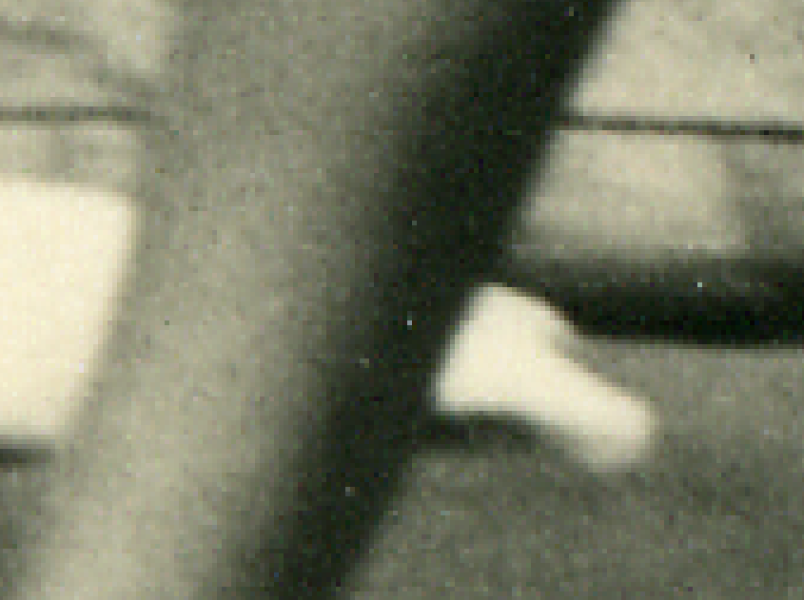

**GIF: 500%**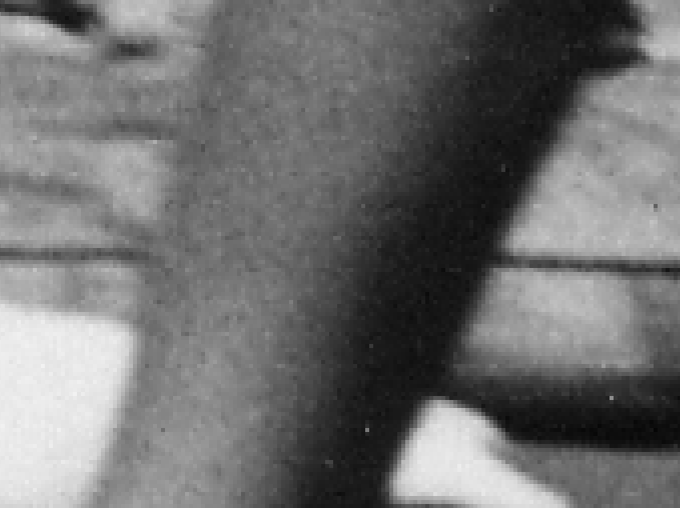

**Jpg: 50%**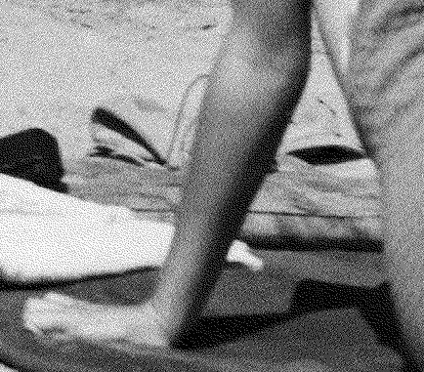

* 1. Briefly give your view on the trade-offs between file size and quality of images.

Although it provides great detail and quality, this requires, extra space for files of this type. If files are always saved in this format, extra space is required which could get costly. On the other hand the smaller the file size the lower the quality in detail.. Compressing the file to other formats to make file size smaller removes data lowering the quality. High quality is the best, but finding a quality that is good enough for the intended use is something that many consider when dealing with cost and space available,