Aleph/Pegasus Library Catalog: An Evaluation of a Library’s Web-Based Catalog
Ashley Luna
San José State University
LIBR-202-13 Information Retrieval

Author Note
Ashley Luna, Graduate Student of Library and Information Sciences, San José State University.
Correspondence concerning this article should be addressed to Ashley Luna,
E-mail: ashley.luna@students.sjsu.edu
Abstract
This paper serves to evaluate the search features and interface design of the UC Santa Barbara () Library Catalog. The system uses Aleph as its OPAC, while using Pegasus as its database to store records. Descriptions of some of the index mechanisms are discussed, while precision measures are conducted to evaluate search effectiveness. An evaluation based on perceived user experience is conducted looking at many of the search features that the catalog provides. Interface design is also looked at for usefulness and ease of access to prospective users. This evaluation serves to highlight the Library Catalog’s strengths, while looking at some of the limitations it provides compared to other information retrieval systems.

System Overview and Background
The () library catalog is a web-based catalog for an academic research institution. The library catalog uses ALEPH as their OPAC system for their library holdings. The Aleph Integrated Library System allows the Library to integrate with other 3rd party applications through a XML gateway and continuously allows the library the ability to grow and expand (Library of Congress, 2012). This OPAC was implemented to the Library in 2001 and is used to import, store, retrieve, and export bibliographic, patron and financial data related to library resources. The Library Catalog is one application in ALEPH that interfaces with other campus applications and applications external to , such as Classic and Next Generation Melvyl (Library Technology Guides, 2001; Library, 2010).
The library Catalog uses a database called Pegasus that ALEPH connects too. Using this host/IP http://pegasus.library..edu users are connected to the library catalog where they can search for books, serials, electronic resources, manuscripts, audio-visual materials and any other materials available at this research institutionAll records are available to the public so there is no need to be a student to search the catalog as long as you have an Internet connection. For some Internet resources you need to be a student or faculty member to view the actual resource if looking from a computer outside of the Campus or proxy server.
Collection Scale and Indexing Mechanisms
The collection scale for this catalog is quite large compared to most libraries in the area of Santa Barbara. The library holds the following in their collections:
- Print Volumes: 3 million
- Electronic Journals: 30,000
- E-Books: 34,450
- Digitized Items: 900,055
- Maps: 500,000
- Cartographic Images & Aerial Photos: 5 million
- Sound Recordings: 167,500
- Manuscript Collections: 4,100 (, 2012)

Everything the library owns, or items in the process of becoming part of the library collection, are available as a record to look up. All items are MARC tagged and are also stored in a different database where the OPAC, ALEPH, connects and retrieves the information. The information available in the MARC tag lets the retrieval system know which fields are access points. The access points are indexed, and searches can be done through these access points. Every word in a field that is an access point is also searchable and automatically indexed. A handful of terms in the metadata are also indexed so these terms become keywords that the catalog searches. For example, author’s name is an access point and keyword, while notes, chapter titles, and summaries are all made keywords.
A number of searches were conducted using the most common stop words and the system dose implement some stop words. For example, a search on “women of color in art history” will bring up a list where all terms in the records excluding “of” are boldfaced. This search shows that “of” is not included in the search query but “in” is. Although users have the option to select “Words as phase,” “of” is still not included in the search. Another example is a search for “the life of Marilyn Monroe ”. When a default search is conducted, “the” and “of” is not included. When the “words as phrase” option is selected, “life” and “Marilyn Monroe” is boldfaced while “the” and “of” is not. It is interesting to note that in this search “the” and “life” and “of” “Marylyn Monroe” are right next to each other in these records. Although “the” and “of” are not included, the proximity of these words are the same because of the “words as Phrase” option. The following are some of the stop words that are used: the, of, and, or, an.
When conducting searches, all search features, except browse search, have the ability to use Boolean logic within the search fields. In this library catalog Boolean words “and,” “or” and “not” are utilized. In this library catalog stemming dose not occur, but truncation and proximity are allowed using a set of guidelines available at the bottom of the page or in the help menu. Here is an example of their truncation and proximity guidelines:
“The ? character or * character (asterisk) may be placed at the left, right or middle of a portion of a word, but it can never be used more than once in a text string.
The # symbol can be used to find variant spellings in cases where one version of the word has one more character than another version.
The % symbol, followed by a number, may be placed between two words to indicate that you want the words to appear within a particular distance from each other, and you don't care what order the words appear in.
The ! character, followed by a number, may be placed between two words to indicate that you want the words to appear within a particular distance from each other, and in the same order in which you type the words ( Library, Help contents).”
These guidelines show how the system retrieves information with the option to expand and limit terms to retrieve within its metadata and indexes.
This library catalog searches by term availability and frequency based on search criteria and search result display. The numbers in descending order indicate which records hold the most terms from the search. The default settings do not allow phrase searching and result display is by year then author in numeric and alphabetical order. For example, a search for “women and art” in the search default settings will produce the following :
- women=1; art=2
- women=2; art=1
- women=1; art=2
- women=2; art=1
It is important to note that the first record represents a search where “women” appears first in the records. Records 1-4 indicate that these record hold terms of the search query. The system searched through all the library records and produced 6753 results, where all records that contain “women” and “art” are pulled up in the same pattern shown above. When browsing through indexes, such as subject or author indexes, results are also in alphabetical or numeric order. When browsing for “women and art” by subject, all records that hold “women”, even if they don’t hold “art,” are retrieved. This is because the system is looking for all subjects that begin with “women.” Interesting to note that the first record retrieved is an authority record for women and architecture, which is related to art but not the term “art”. In browse mode the system produced an index with the most records related to the field of art, while the search produced only records with “women” and “art” due to the presence of a Boolean operator.
Search Features and Functions
The Library Catalog implements a number of search features and options that provides the flexibility to conduct different types of searches depending on the skill levels of potential users. When entering the catalog at http://pegasus.library..edu a user is automatically set with the catalog’s default search features. The Basic search option is the default search type that comes up. There are a number of search options to choose from the drop down menu to specify the type of search that is conducted. For example there is a search by keyword, author, title, and ISBN. The default search in basic search is by keyword with “no” selected in “Word as Phrase.” This is the most basic search that users utilize with some level of control. The basic search feature allows users to make quick searches, although this will produce a significant amount of results because of lack of specification. Since this is the first screen seen, users will typically use this first before moving on to other search features.
The next search feature available is the Advanced Search. The Advanced Search allows a user more control to produce the exact results. In Advanced Search three search fields are available with drop down menus to customize searches. When a search is conducted each field produces its own record results with an addition of another total that displays which records contain the criteria of all three fields. Advance search also features search limitations such as year span, location in library, type of format and language. This allows a user to limit and narrow search quires and is useful in looking for specific results. The Advanced Search is typically used for records in which a user already knows most of the information that the search will entail.
Another set of search features is the Advanced Browse search, Course Reserve Search and New Titles Search. Advanced Browse allows a user to search through author, subject, title, serials, and call number indexes. A user enters a search keyword and the system produces a list of indexes to browse. For example a search on Art history by “subject begins with…” will give you indexes related to Art history, such as , Art -- History -- 16th century. In the Course Reserve a user can search by course number, instructor, title, author and call number. After a search is conducted this index will pop up for that class. In the New Titles Search, the index is searched based on keywords, location, format, language and Date range ( Example: Last 60 days) on any new materials the library receives. Another way to access indexes in any record is through the access points that are underlined. When clicked, a list of related indexes appears. This type of searching is useful for a user who knows very little about a subject. A user has the ability to browse all these indexes without out knowing the exact search query. It also allows a user to look at similar records within the index to help formulate other searches. These type of searches allow a user to search and browse through some of the library’s catalog indexes.
The last search feature available is the Command Line search using abbreviations from the ALEPH command language. There is only one field available and abbreviations for commands require an “=” sign to complete. For example, a search for impressionism in the notes field would look like this:
WNT=impressionism
(See Appendix A for Command line search and Aleph Command language).
This type of search is designed for advanced users who want to preform complex and complicated searches. A typical user might have a problem using this type of search because it requires some time to formulate a specific search query. A librarian rather then a typical user would find these search features very useful for advance searches.
Search Effectiveness
Recall is difficult to assess given the grand scale of the library collection. Instead, a search was conducted in Basic and Advanced search, to formulate precision percentages. Command line search was not evaluated given the number of possibilities one could formulate with the command language. Basic Search produced an average of 80% precision, and advanced search produced 93% (see Appendix B for precision calculations). The library catalog is effective if a user already knows a specific search query. The boarder the search query, the less effective the search is. It was also interesting to notice that the broader the search, the more time it took the system to produce results. Given these results, search effectiveness also depends on the skill level of the searcher and the type of search queries that are formulated. A novice might produce a different result.
Quality of Interface Design
The library catalog’s interface layout is simple with tabs and menus running horizontally, while providing useful features. There are no graphics and ratings but the design is traditional of a library catalog (Appendix C). As discussed above, the Basic Search is the default search that a user immediately see’s. The Basic Search is very straightforward and allows a user some control with out having advanced searching skills. If a user wants more control there is a link for advanced search in the basic search window. A user will have fast and easy access to both the basic and advance searches. For more advance searches a user will have to go out of their way into the drop-down menus of search. Although a user has to go out of their way, the search menu tab is conveniently located as the first menu on the far left.
There are a number of review results features that are very useful in this library catalog. When search results are displayed the default settings are set to organize records by year then date. Within the record results, a user can click on author, title, year and format to change the order to fit their needs. The library catalog also features a “Review Results” tab with a menu that provides significant features, such as, current results, search history, my temporary list and clear search. The current results link allows users to go back to their last results from any point or window. This is useful because it is quick and does not require a serious of back button clicks or a repeat of the same search. In search history users can look at pervious searches if they need to backtrack their searches or combine their searches. As a result, users can navigate without fear that they will lose their results while saving time from repeat searches.
Another important feature is the ability to limit searches, within search results. When conducting searches a user can limit their search results by clicking “limit results”. This takes them to a screen where users are promoted to choose a Boolean operator, keyword and optional limitations such as format, years, location and language in a step-by-step format. This type of display takes a user step by step in the process of conducting a specific search (Appendix D).
The help features are also very prominent throughout the catalog. In all search windows there are search hints and tips at the bottom of the page. There is also a Help tab that also provides useful information when conducting searches. I found that some of the tips at the bottom of the searches where not available in help. This could be confusing for a user who would like clarification about the search tips. Despite this issue, the help features allow users who are unfamiliar with searching techniques to conduct better searches.
Another limitation is that search result displays only display the most important record information. This results in the user having to click open the record to see if it is relevant. A short summary or abstract of each record in the search result window would minimize searching time since a quick scan from record to record would help form faster judgments.
Conclusion
The Library Catalog is a catalog that mainly focuses on retrieving bibliographic and location information for users in a research institution. The institution attracts a high number of users, about 1.6 million visitors a year ( Library, 2010). As a result more focus is produced on producing and retrieving the most relevant information, then attracting users with other features like ratings. The basic search by itself produces relevant results when conducting searches. For advanced searching, a basic knowledge of subjects and keywords is needed, while command search requires some expertise. Given the help and search features, a novice user could find relevant materials but it does take some time to figure out where some of these search features are displayed and their functions. Some of the search features require searches to be conducted first, before discovering the more advance features. The skill level of the user will affect the relevance of results, if there is not a basic understanding of how catalogs function. As a whole, the library Catalog produces relevant results if there is a basis understanding of its functions and searching tools.

References
Chowdhury, G. G. (2004). Introduction to modern information retrieval. London: Facet
Publishing.
Library of Congress. (2012). MARC systems. Retrieved October, 2012, from http://www.loc.gov/marc/marcsysvend.html
Library Technology Guides. (2001). The libraries are moving to a new web-based catalog system. Retrieved October, 2012, from http://www.librarytechnology.org/ltg-displaytext.pl?RC=9012
Library. (2010). About the library. Retrieved October, 2012, from http://www.library..edu/about
Library. Help contents. Retrieved October, 2012, from http://pegasus.library..edu/F/S9FX16U394CU341S81CMG13F88DBMYMLGGCMCJLXRXH59NHSKY-10626?func=file&file_name=help-1&local_base=sba01pub#find
Library. (2010). Software/Web Services and ILS Unit. Retrieved October, 2012, from http://www.library..edu/lis-digital/sws-ils-unit

Appendix A

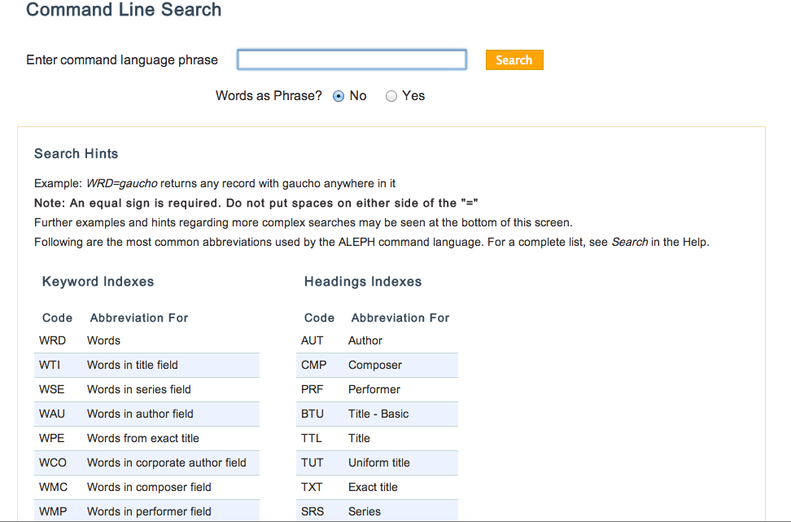

Full list available at: http://pegasus.library..edu/F/S9FX16U394CU341S81CMG13F88DBMYMLGGCMCJLXRXH59NHSKY-67664?func=file&file_name=help-1&local_base=sba01pub - command

Appendix B
Basic Search
I choose the name Berthe Morisot because she is a specific female impressionist artist that would show up in a academic research institution’s library holdings.
The first search was a basic search using the default settings :
Precision= (51)/(51)x100=100%
Another search in Basic using the terms “Mexican women painters” produced:
Precision=(20)/(20)x100=100%
A broader search using keywords “victorian homes” produced:
Precision=(12)/(30)x100= 40%
Average precision is 80% in Basic Search
Advanced Search
In advanced search the following search was conducted using keywords “women” and “feminism”, subject “art history”:
Precision=(34)/(38)x100=89%
Another search using keywords “surrealism” and subjects “20th century” and “art history” formulated the following:
Precision=(26)/(29)x100= 90%
A third search using subjects “curatorship,” “art” and “technology” produced:
Precision=(2)/(2)x100=100%
Average precision 93%

Appendix C
Default Basic Search Screen

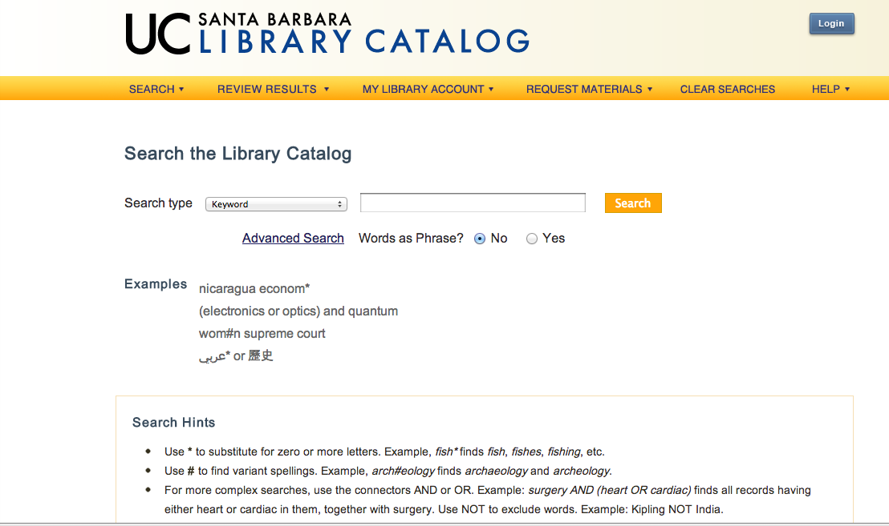

Appendix D
Limit Results Screen
